- Name | Dr. Harshada Parashare- Aurangabadkar | 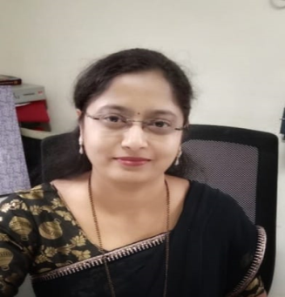Photo
Designation | Asst. Prof.
Department | Management
Educational Qualifications | MBA(Finance), M.Phil, Ph.D
Total Experience In Years | Total Experience : 18 Years  Academic Exp.: 11 Years  Industrial Exp.: 7 Years
Areas of Interest | Financial Management, Strategic Management, Portfolio Management, Investment Management, Banking
Papers Published | 18
Papers Presented In Conferences | 10
Books Published | 02
Affiliations/ Memberships
Consultancy Activities
Awards | 1
Grants Fetched
Interaction With Professional Institutions

